# Using Background Processing to Build Scalable Applications with Hangfire

## Lab 4

### Goal

Hangfire supports a number of job types: Background Jobs, Recurring Jobs, and Delayed Jobs. So far our application only uses Background Jobs. In this lab we will convert one of our Lemming Jobs to be a Recurring Job: that is our Lemming will continuously perform their work according to a schedule which we define.

1. Open the Startup.Hangfire.cs file in the App_Start folder inside of the Web project.
2. Copy the following using statements into the partial Startup class

using System;

using System.Linq.Expressions;

using Core.Jobs;

1. Copy the following into the partial Startup class:

private static void ConfigureRecurringJobs()

{

    SetupRecurringJob<BuildHouseJob>(j => j.Run());

}

private static void SetupRecurringJob<T>(Expression<Action<T>> job) where T : BaseLemmingJob

{

    RecurringJob.AddOrUpdate(job, Cron.Minutely);

}

In the SetupRecurringJob<T> method, note how our job is configured: by using the AddOrUpdate method on the static RecurringJob class, in addition to the method parameter, the AddOrUpdate method takes Cron expression indicating the frequency by which the job should run. Hangfire offers a helper class which can be used, as we have done here to specify that the job should be run every minute. More detailed Cron schedules can be defined. Please see <https://en.wikipedia.org/wiki/Cron#CRON_expression> for more information about Cron expressions.

1. Next, add the following line to the end of the ConfigureHangfire method in the partial Startup class:

ConfigureRecurringJobs();

1. Now, with our recurring job configured, press F5 to run the application. Let your application run, and you should see the number of Home Jobs increasing, without the need to manually queue the jobs.



1. Open a new tab in your browser and navigate to the Hangfire Dashboard (<http://localhost:13161/hangfire>).
2. On the navigation bar at the top, click Recurring Jobs.



1. On the Recurring Jobs page, you should see our BuildHouseJob listed.

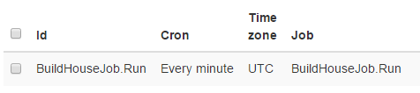

1. If you would like to manually execute a recurring job, simply check the checkbox for the specified job, and click the Trigger Now button located towards the top of the list.

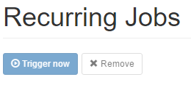

1. Additionally, if you would like to Remove a Recurring Job, simply check the checkbox for the specified job, and click the Remove button located towards the top of the list. Removing a recurring job can be helpful when deploying an application to a test environment when running the recurring jobs may not necessarily be desirable.

This completes Lab 04.